Superstores data using pivot charts

# Data Overview:

The dataset chronicles the sales of a nationwide superstore, encompassing all US states and regions. Products fall into three key usage segments: Consumer, Home Office, and Corporate. Each segment further branches into three main categories:

* Furniture: Bookcases, Furnishings, Chairs, Tables
* Office Supplies: Appliances, Envelopes, Labels, Storage, Art, Fasteners, Paper, Supplies
* Technology: Accessories, Machines, Copiers, Phones

# Data Structure:

The data resides in a tabular format with the following key fields:

* Order IDs: Unique identifiers for each purchase.
* Date Stamps: Order and shipment dates.
* Shipping Mode: Delivery method used (e.g., Standard, Expedited).
* Customer Information: ID, name, and segment.
* Product Details: ID, category, sub-category, name, sales figures, quantity, discount, and profit.

# Workflow:

Recognizing the inherent structure, I prioritized data exploration for proper interpretation and analysis. Pivoting offered a powerful tool to build insightful tables, facilitating trend discovery and hidden pattern identification. For instance, pivoting category against regional sales totals unveiled valuable insights into sales distribution across geographical segments and product categories.

# Next Steps:

This initial exploration lays the foundation for further analysis. We can leverage this granular data to delve deeper into:

* Regional Performance: Understanding variations in sales patterns across different states and regions.
* Segment Analysis: Identifying top-selling product categories within each customer segment.
* Sub-Category Trends: Drilling down to uncover high-performing and underperforming sub-categories within each main category.
* Quantifying Fluctuations: Exploring Quarterly Sales Patterns Across a Four-Year Period
* Profitability Insights: Evaluating the relationship between sales, discounts, and profit margins across various product segments and regions.

By harnessing the power of data analysis, we can unlock valuable insights that can inform strategic decision-making and boost the superstore's operational efficiency and profitability.

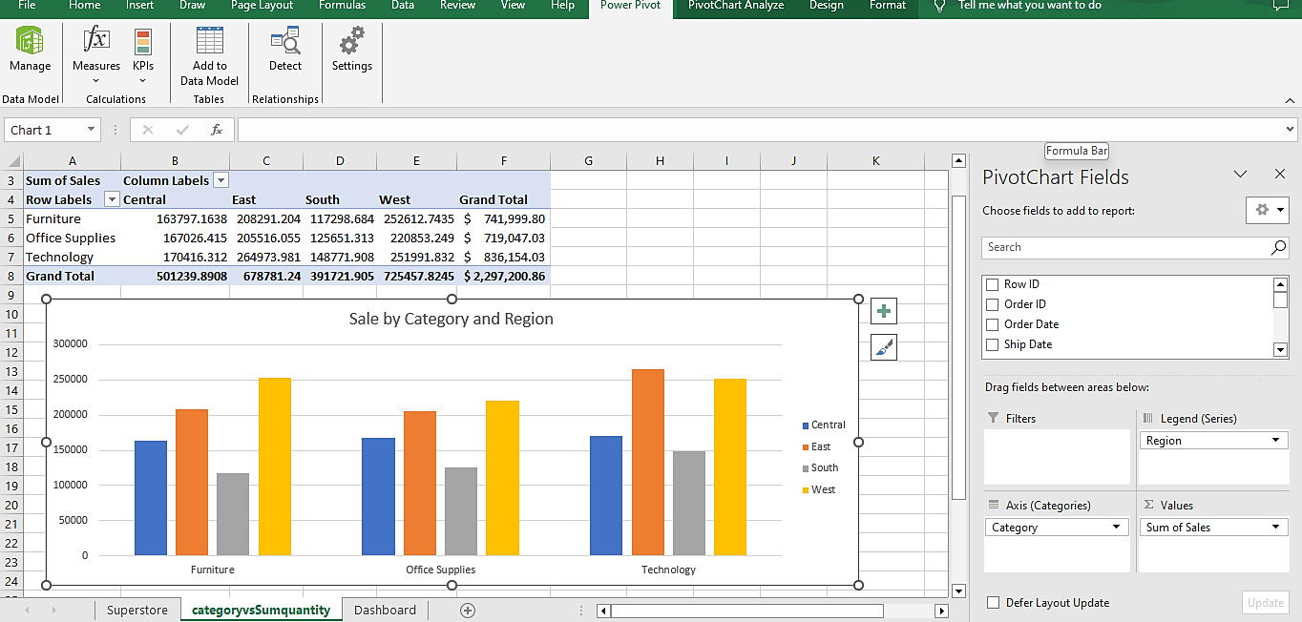

Figure : Category vs Sum of Sales

In my quest to understand how the segments stacked up during the analysis, a head-to-head performance evaluation was in order. To shed light on the metrics across segments, the trusty pivot chart became my sidekick once again. I could readily spot segments that consistently outperformed others, as well as those lagging behind.

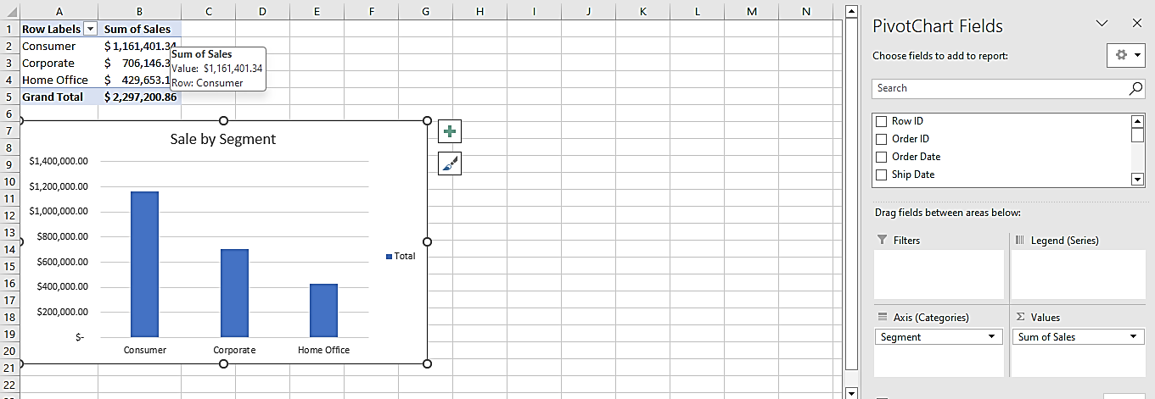

Figure : Segment vs Sum of Sales

For the sub-category trends, this analysis was done such that each the category is reflected in the chart to create a better understanding of the breakdown. The table shows the quantity sold for each of the subcategories and the total units sold in the period under review.

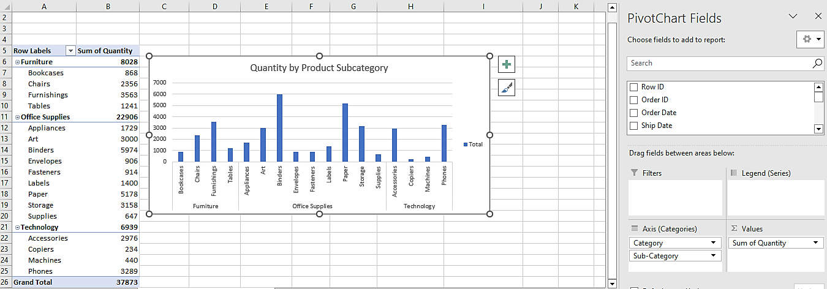

Figure : Quantity by Product Subcategory

For the quarterly sales fluctuations, a table showing all the quarterly performances of each of the years under review as well as the totals per year. This gives insight into the performances of both the year-on-year and the quarters.

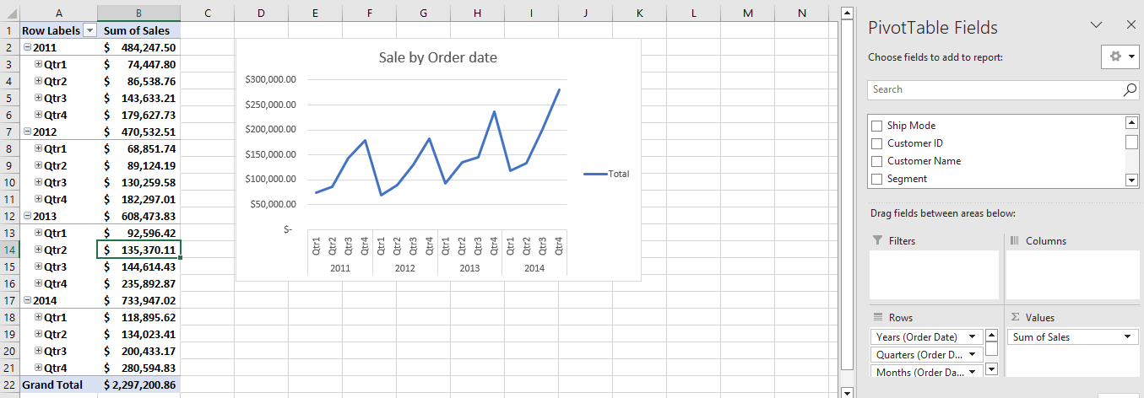

Figure : Sales by Order date

For the profitability, a table showing the sum of the profits by the category was designed to give us a summary of the most profitable category. A pie-chart was used to represent this analysis for a straight-forward visual representation. In addition to this table another table was added to the eventual dashboard that summarises all the monthly discounts enjoyed by the three(3) categories.

Also, four slicers(4) was added to aid filtering and narrowed down analysis of specific products, categories, segments or even a time period.

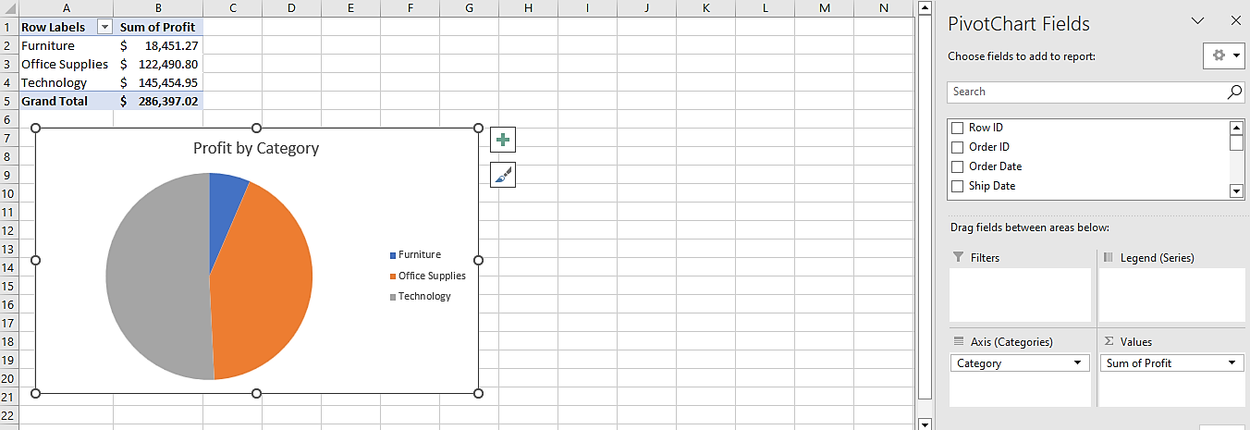

Figure : Profit by category

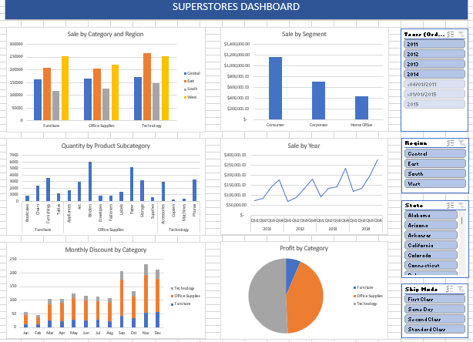

Figure : Dashboard summarising all variables

Insights gotten from the analysis are as follows:

* The western region is the region with the highest patronage of the store during this period with a total spend of $725,457.82 while the Southern region is the region with the least patronage with a total spend of $391,721.91.
* The Technology category is the category with the most sales with a total of $836,154.03 which amounts for 36.4% of the total accrued in the four-year period. The office supply category performed the least of the period with a total $719,047.03, this amounts to 31.3% of the total.
* The consumer segment had the most sales with a total of $1,161,401.34 which amounts to 50.6% of the total sales of the three segments. The Home office segment is the least performing of the three with a total sale of $429,653.15 which amounts to 18.7% of the total accrued in the four years in review.
* The orders are usually low in the first quarter of every year but then slowly pickup throughout the year. The fourth quarter of each of the years had the highest orders with 37.1% for year one, 38.7% for year two, 38.8% for year three and 38.2% for the fourth year.
* The technology category sold the least number of items will the furniture category sold the highest number of items. Copiers is the least sold item with just two hundred and thirty-four (234) pieces being sold during the period under review while binders is the most sold item with five thousand nine hundred and ninety four (5974) pieces being sold in the same period.
* Furniture category is the least profitable of the three with a total of $18,451.27 which amounts to a mere 6.44% of the total profit made while the technology category is the most profitable with $145,454.95 of the total profit made in that period. This amounts to 50.8%.

# Recommendations

In view of all the insights, the following recommendations are suggested:

* Focus on the West: With such dominance, the western region deserves special attention. Understanding their preferences, demographics, and marketing channels can unlock further growth opportunities.
* Engage the South: While spending might be lower, the southern region still holds potential. Tailored marketing campaigns and product offerings could attract more customers and boost their spending.
* Don't Neglect the Others: The eastern and northern regions, although smaller spenders, shouldn't be ignored. Analyzing their unique characteristics and preferences can lead to effective regionalized marketing strategies.